This is the ‘**Main Page**’ after signing Up

and **succeed** to get the data…

‘**Main Page’** while the data is **loading**



**'Main Page'** when the data has **Failed**

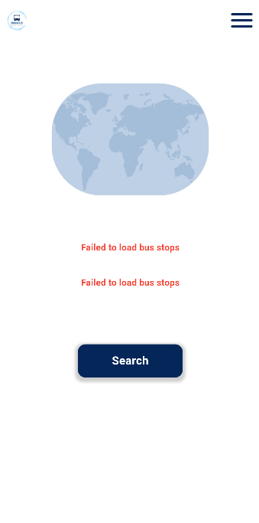

‘**Main Page’** after **succeed** of getting data

and **selecting** the bus stops two points

from the list.

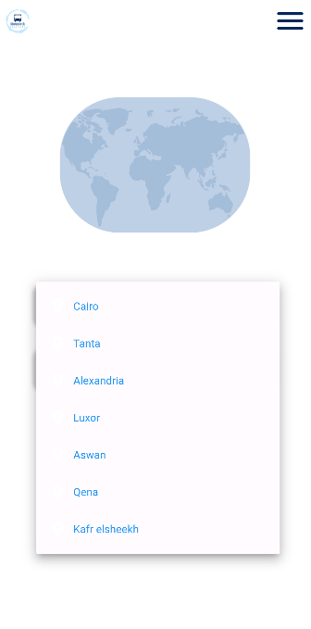

‘**Main Page’** when **selected** the bus stops

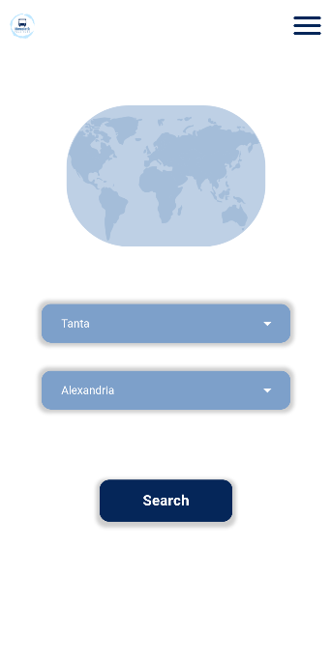

‘**Search Page’** when **selecting** points

and **clicking** on Search button.

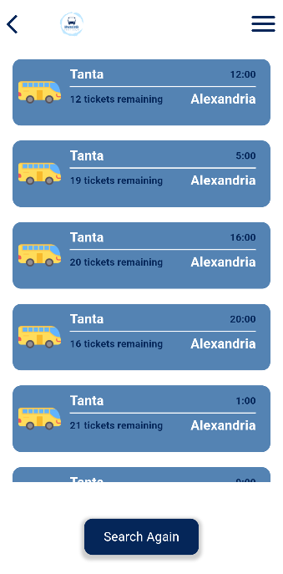

This is the list of all journeys

from the start point bus stop

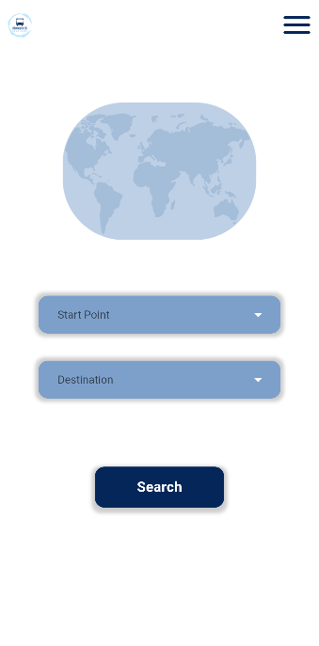to the destination bus stop

When selecting Search Again button

It opens ‘**Main page’** to select

deferent points..

This is ‘**Journey Page’** when selecting a certain journey

from the ‘**Search Page’**

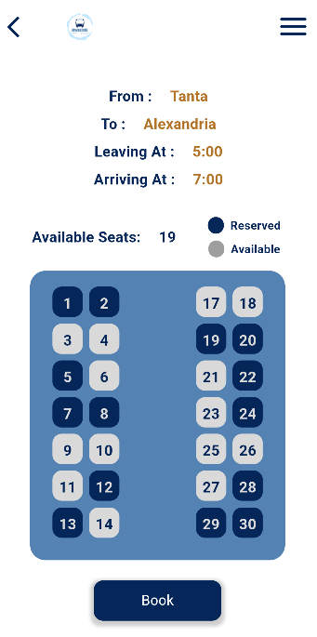

This Page explains the details

of the certain journey

and shows the seats that available

to allow the user to choose his seat

When **selecting** the seat to reserve it

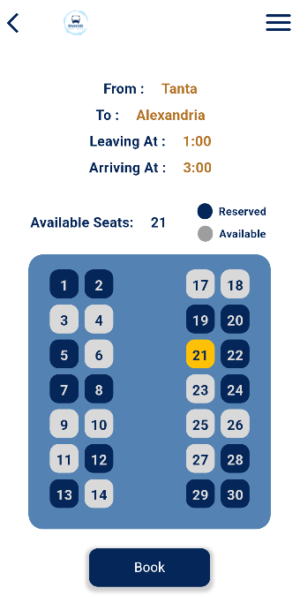

When selecting **Book** button at ‘**Journey Page**’

it opens ‘**Booking Page**’

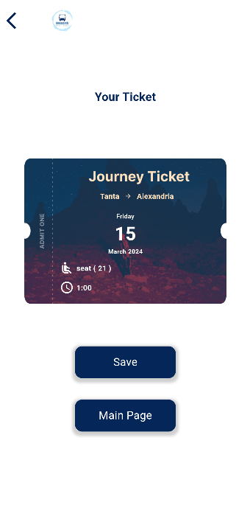

This is the **Ticket** and shows

all the journey details

The **Save button** saves

the ticket photo

at the gallery

The Main Page button goes to the ‘**Main Page**’ screen

This is the ‘**Drawer**’ it opens when clicking the icon at the Top Right of some Pages

like ‘**Main Page’**, **’Search Page’**, **‘Journey Page’**

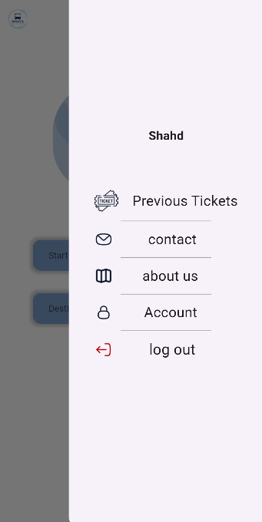

This is the Name of the user

Previous Ticket button opens

‘**Previous Tickets Page’**

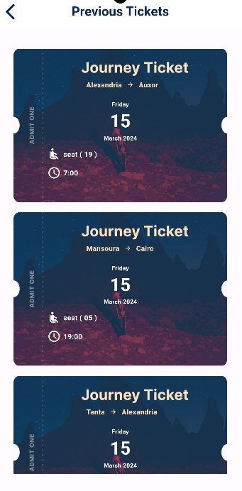Log out Button return to

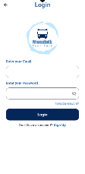 ‘**Log In Page’**

The ‘Drawer’ Icon

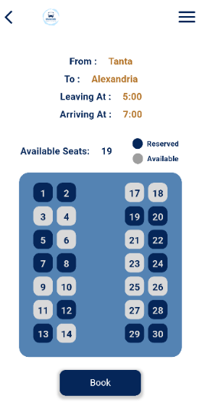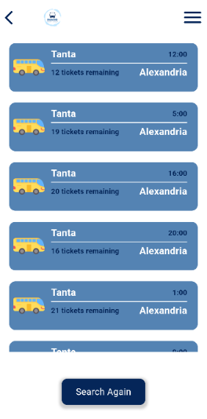

This page shows the previous

Tickets that the user

reserved before